Experiment 1: 8 Queens Problem

Aim
To solve the 8 Queens Problem using the Backtracking algorithm so that no two queens attack each other.

Objective
To place eight queens on an 8×8 chessboard such that no two queens are in the same row, column, or diagonal.

Algorithm
- Start the program.
- Create an empty 8×8 chessboard.
- Begin placing queens from the first column.
- Check whether the current position is safe.
- If safe, place the queen.
- Move to the next column and repeat the process.
- If no safe position is found, remove the previously placed queen (backtrack).
- Continue until all eight queens are placed.
- Display the solution and stop.

Flow chart
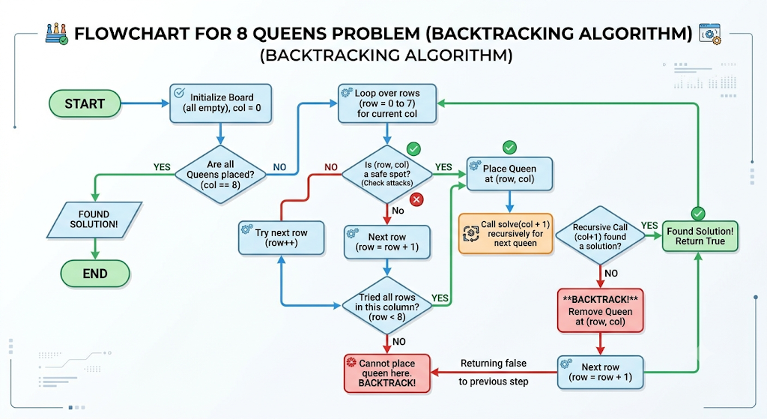

Python code
N = 8

board = [[0] * N for _ in range(N)]

def safe(row, col):
for i in range(col):
if board[row][i]:
return False

i, j = row, col
while i >= 0 and j >= 0:
if board[i][j]:
return False
i -= 1
j -= 1

i, j = row, col
while i < N and j >= 0:
if board[i][j]:
return False
i += 1
j -= 1

return True

def solve(col):
if col == N:
return True

for row in range(N):
if safe(row, col):
board[row][col] = 1

if solve(col + 1):
return True

board[row][col] = 0

return False

solve(0)

for row in board:
for cell in row:
if cell == 1:
print("Q", end=" ")
else:
print(".", end=" ")
print()

Input
Number of Queens = 8

Output
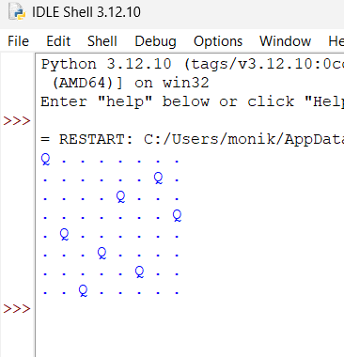

Result
The 8 Queens Problem was solved successfully using the Backtracking algorithm, and all eight queens were placed on the chessboard without attacking each other.

